Ysgol Gymraeg Gwynllyw

Cluster Transition Policy

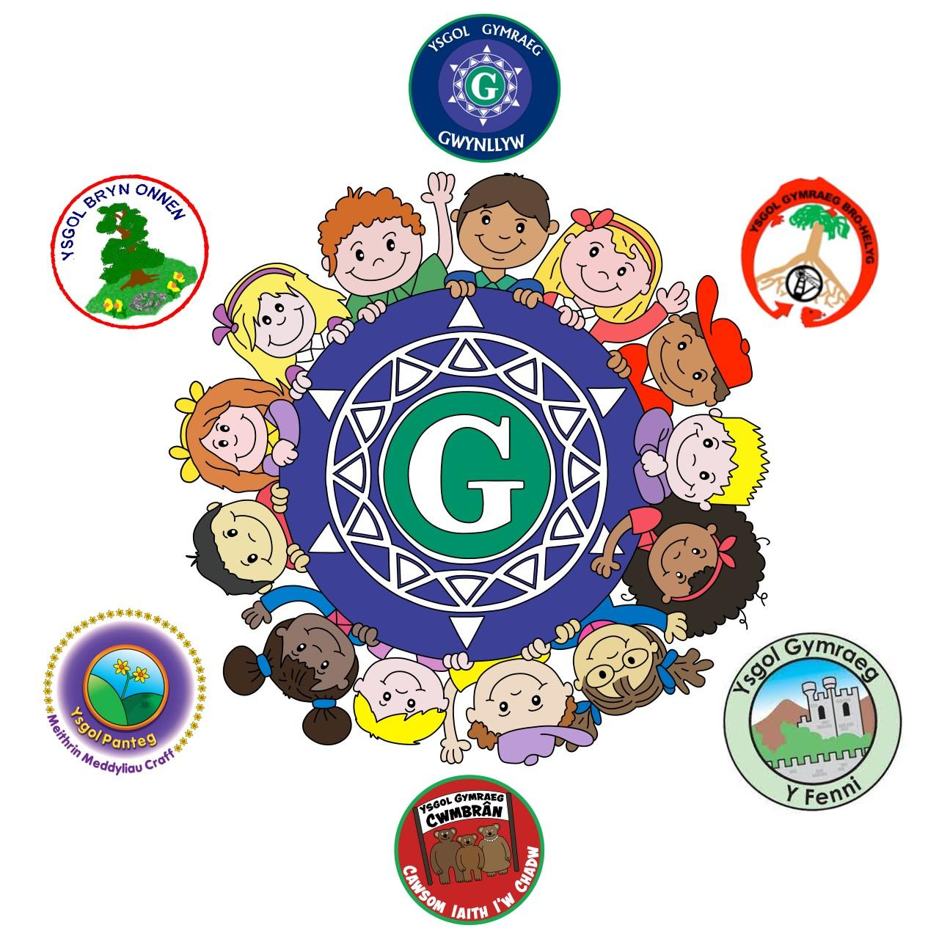

PRIMARY TO SECONDARY TRANSITION POLICY

This transition policy is a joint agreement between the following schools:

Ysgol Gymraeg Gwynllyw (Torfaen)
Bro Helyg Gymraeg School (Blaenau Gwent)
Bryn Onnen Gymraeg School (Torfaen)
Ysgol Gymraeg Cwmbran (Torfaen)
Ysgol Gymraeg y Fenni (Monmouthshire)
Ysgol Gymraeg Panteg (Torfaen)

HEADS IN THE PARTNERSHIP

Gwynllyw Gymraeg School –Mr Mark Jones
Ysgol Gymraeg Bro Helyg –Ms Ann Toghill
Bryn Onnen Gymraeg School –Mr Rhys ap Gwyn
Ysgol Gymraeg Cwmbran –Miss Catrin Evans
Abergavenny Welsh School –Ms Sarah Oliver
Panteg Gymraeg School –Dr Matthew Williamson-Dicken

Deputy head -Mr Gareth Jones
Assistant Head – Mrs Rhian Dickenson
Transition Coordinator –Mr Richard Davies
CADY Gwynllyw –Mrs Anna Davies

PURPOSE

Our agreed aims are:

- Prepare secondary school pupils for the experience of transferring to secondary school.
- Promote the progression of the pupils' education between the key stages.
- Ensure that information for transferring pupils is provided and used appropriately.
- Ensure that the pupils settle in a completely safe environment.
- Ensure that the pupils and their parents are fully informed about the transfer process.
- Ensure that the ALNCo goes out to the primary schools, identifies the ALN learners and the vulnerable and plans a program of extended transition for them in order to facilitate the process of transition.
- Ensure that the ALNCo continues to provide specific support for those ALN pupils who are identified.
- Ensuring that MATh pupils are known and that there is provision and a specific and clear learning path for them.
- Ensuring that the Curriculum is suitable for each individual and that there is progression from one key stage to the next.
- Ensure that the process of moderation and assessment is transparent and agreed between the key stages.
- Cultivate greater awareness among staff of the other progression steps, especially the practices and methodology found in it as well as the experience pupils have.
- Sharing expertise and resources. Organise joint training in terms of curriculum developments.
- Work together to ensure that the learners have a coherent curriculum throughout their learning journey.

SCHEDULE

We have an agreed calendar which includes the priorities of the transition plan. The calendar is implemented on several levels - academically and pastorally for the benefit of all pupils who will transfer from one sector to another.

WORKING GROUPS

The cluster has a number of strategic working groups that meet regularly during the year to make decisions on the cluster's work and arrangements. The working groups have an agreed remit.

STEERING WORKING GROUP (CLUSTER HEADS)

The heads of the cluster meet at least every half term to discuss and agree on the cluster's strategic work, identify any additional issues that need attention and, if necessary, agree on the possible further actions. The working group discusses agreed tasks in order to reinforce and enrich the curriculum for Year 6 learners. The working group also agrees on subjects that are focused on and organise joint curricular transition activities.

CURRICULUM DEVELOPMENT WORK GROUPS FOR WYNLLYW

The aim of these working groups is to develop a vision and clear protocols for developing a local curriculum across the cluster. The working groups will agree on common qualities and skills for the cluster's learners in order to ensure a smooth transition to Ysgol Gymraeg Gwynllyw by sharing good practice in terms of procedures and resources and co-planning and co-creating shared learning materials across the cluster .

ASSESSMENT AND PROGRESS WORKING GROUP

- Develop a vision for measuring progress
- Agree on common methods for assessing cumulative attainment
- Share good practice in terms of assessment, recording and reporting methods

WORKING GROUPS AREAS OF LEARNING AND EXPERIENCE (INCLUDING NUMERACY)

- Agree on the qualities of an average learner
- Planning for consistency within the different areas
- Develop ideas for improving learning and teaching.
- Share good practice in terms of methodology.

LITERACY WORKING GROUP

- Develop an agreed strategy in order to develop literacy skills across the curriculum
- Collaborate to create and share common methods of developing literacy
- Raise the standards and expectations of learners especially orally

PRIMARY AND SECONDARY ALN AND WELLBEING WORKING GROUP

This working group includes one teacher from each primary school in the cluster who is responsible for ALN in the school as well as the Year 7 Head of Progress. Issues relating to the well-being of the learners are discussed and we also share good practice to develop awareness of agencies that can support and enrich the curriculum and improve and strengthen the well-being of learners. Some of the agencies that have been discussed together are Barod, CAMHS, Young Carers and Mind. Provision Map is used to transfer information from the primary schools to the Secondary and where possible MyConcern is also used.

ENHANCED TRANSITION

Ysgol Gyfun Gwynllyw ALNC0 works closely with primary schools’ ALNCO in the cluster in order to identify and thoroughly prepare for ALN learners and the vulnerable who transfer to secondary school. The ALNCO organiSes additional visiting days and also regular meetings with parents in order to strengthen the partnership between the parents and the school from the start. The ALN learners receive visits from staff from Gwynllyw, in order to create and establish a partnership so that the journey to year 7 is a successful one. On their visits to Gwynllyw, the ALN learners and the vulnerable are introduced to the Hafan and the Steffan Center provision so that they feel safe and comfortable and get to know the team of teachers and assistants with expertise in the field that will support them as they transition from primary to secondary.

PARENTAL TRANSITION
We make contact with parents / guardians of Years 5 and 6 during the academic year in order to start the partnership of moving from one sector to another. The link takes place regularly throughout the year and includes a variety of activities including:

- Open Evening
- Letters announcing activities
- A welcome letter following the application process
- Additional visits to the school site for those who wish
- Information Night before the start of Gwynllyw
- Contact from the Head of Year in the Summer term.

TRANSITION OF YEAR 5 and 6 PUPILS

It is the transition coordinator's responsibility to get to know learners and attract learners to Gwynllyw. The coordinator will be key in transitioning learners to Gwynllyw creating a relationship with learners and supporting pastoral matters.

Learners will receive an invitation to the open evening in June in the form of a postcard with details of the evening. There will be an opportunity for pupils to look around the school individually with a map or on a tour with the sixth form.

The school will provide a variety of activities to attract learners and ensure a smooth transition including:

- Christmas concert
- A trip to Langrannog (Gwynllyw staff to go on a trip the primary schools organise)
- Right to Question Sessions
- Sports Day
- Taster Days

